PLSQL SQL Plus advanced 1

SQL*Plus: Release 10.2.0.1.0 - Production on Fri Nov 4 11:59:12 2022

Copyright (c) 1982, 2005, Oracle. All rights reserved.

Connected to:

Oracle Database 10g Enterprise Edition Release 10.2.0.1.0 - Production

With the Partitioning, OLAP and Data Mining options

SQL> select * from tab;

TNAME TABTYPE CLUSTERID

------------------------------ ------- ----------

DEPT TABLE

EMP TABLE

BONUS TABLE

SALGRADE TABLE

SQL> select * from dept;

DEPTNO DNAME LOC

---------- -------------- -------------

10 ACCOUNTING NEW YORK

20 RESEARCH DALLAS

30 SALES CHICAGO

40 OPERATIONS BOSTON

SQL> set serveroutput on;

SQL> begin

2 dbms_output.put_line('Hello world');

3 end;

4 /

Hello world

PL/SQL procedure successfully completed.

SQL>

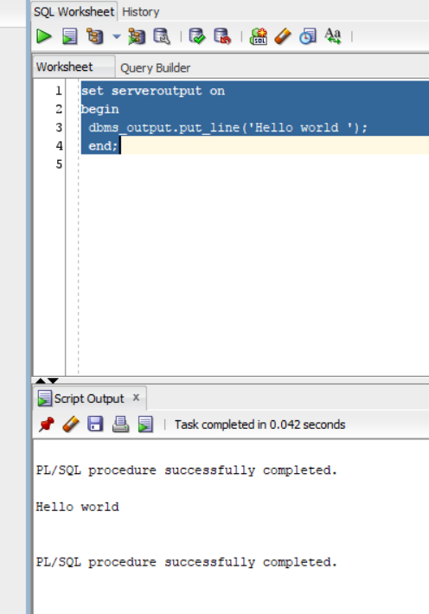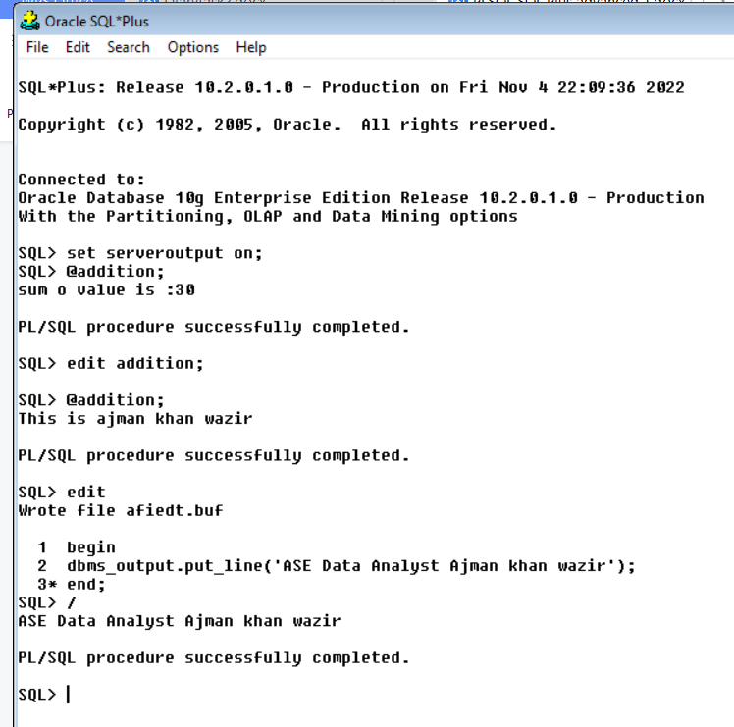

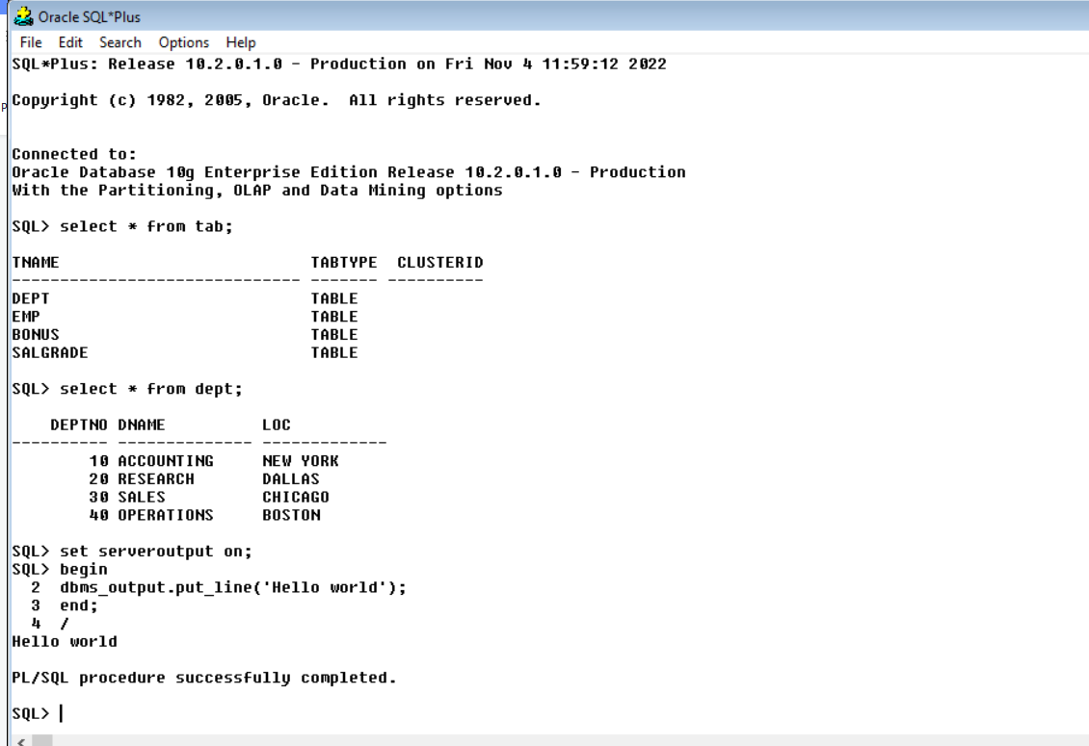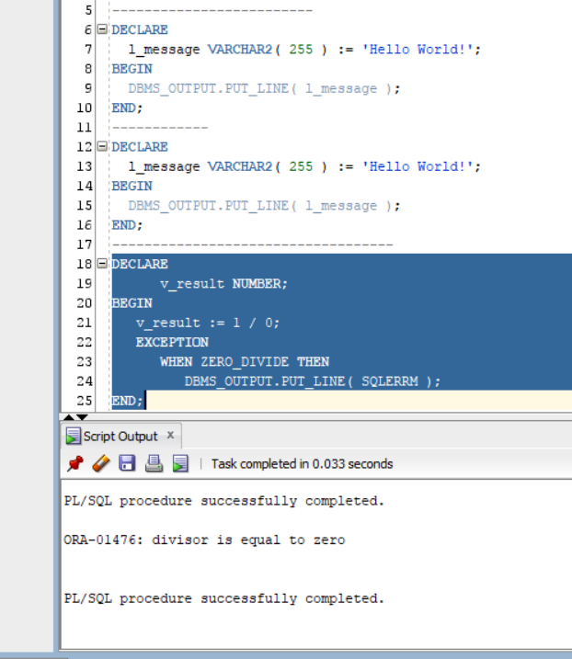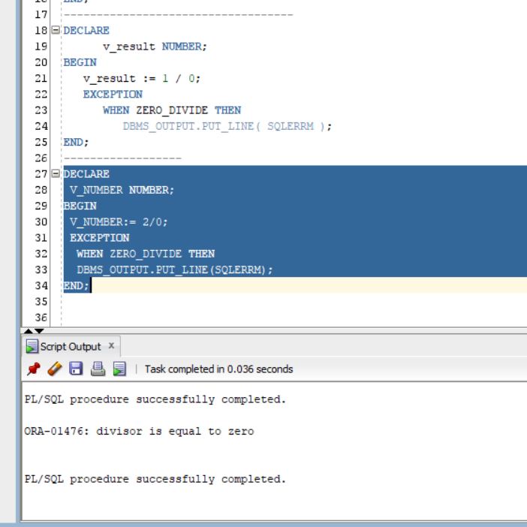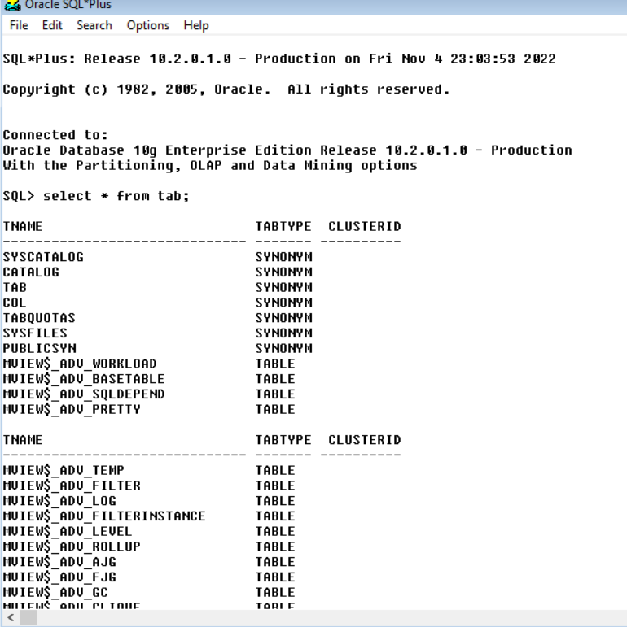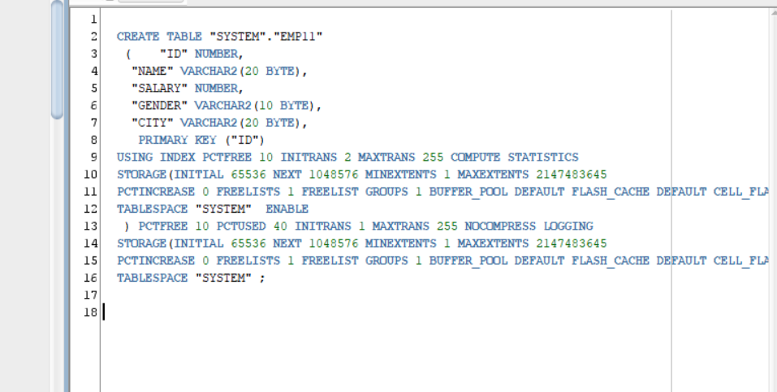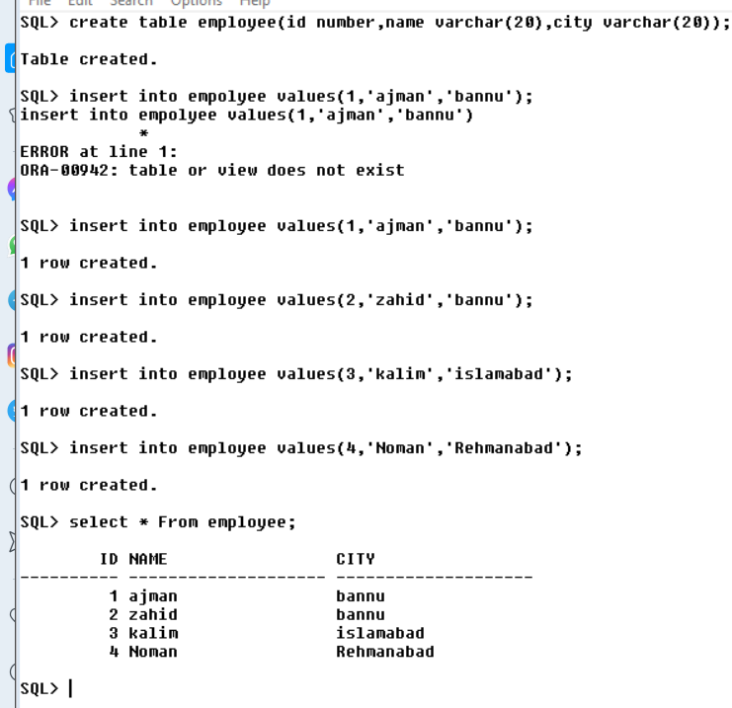

**Links: <https://www.guru99.com/pl-sql-identifiers.html>**

**<https://www.guru99.com/sql-pl-sql.html>**

